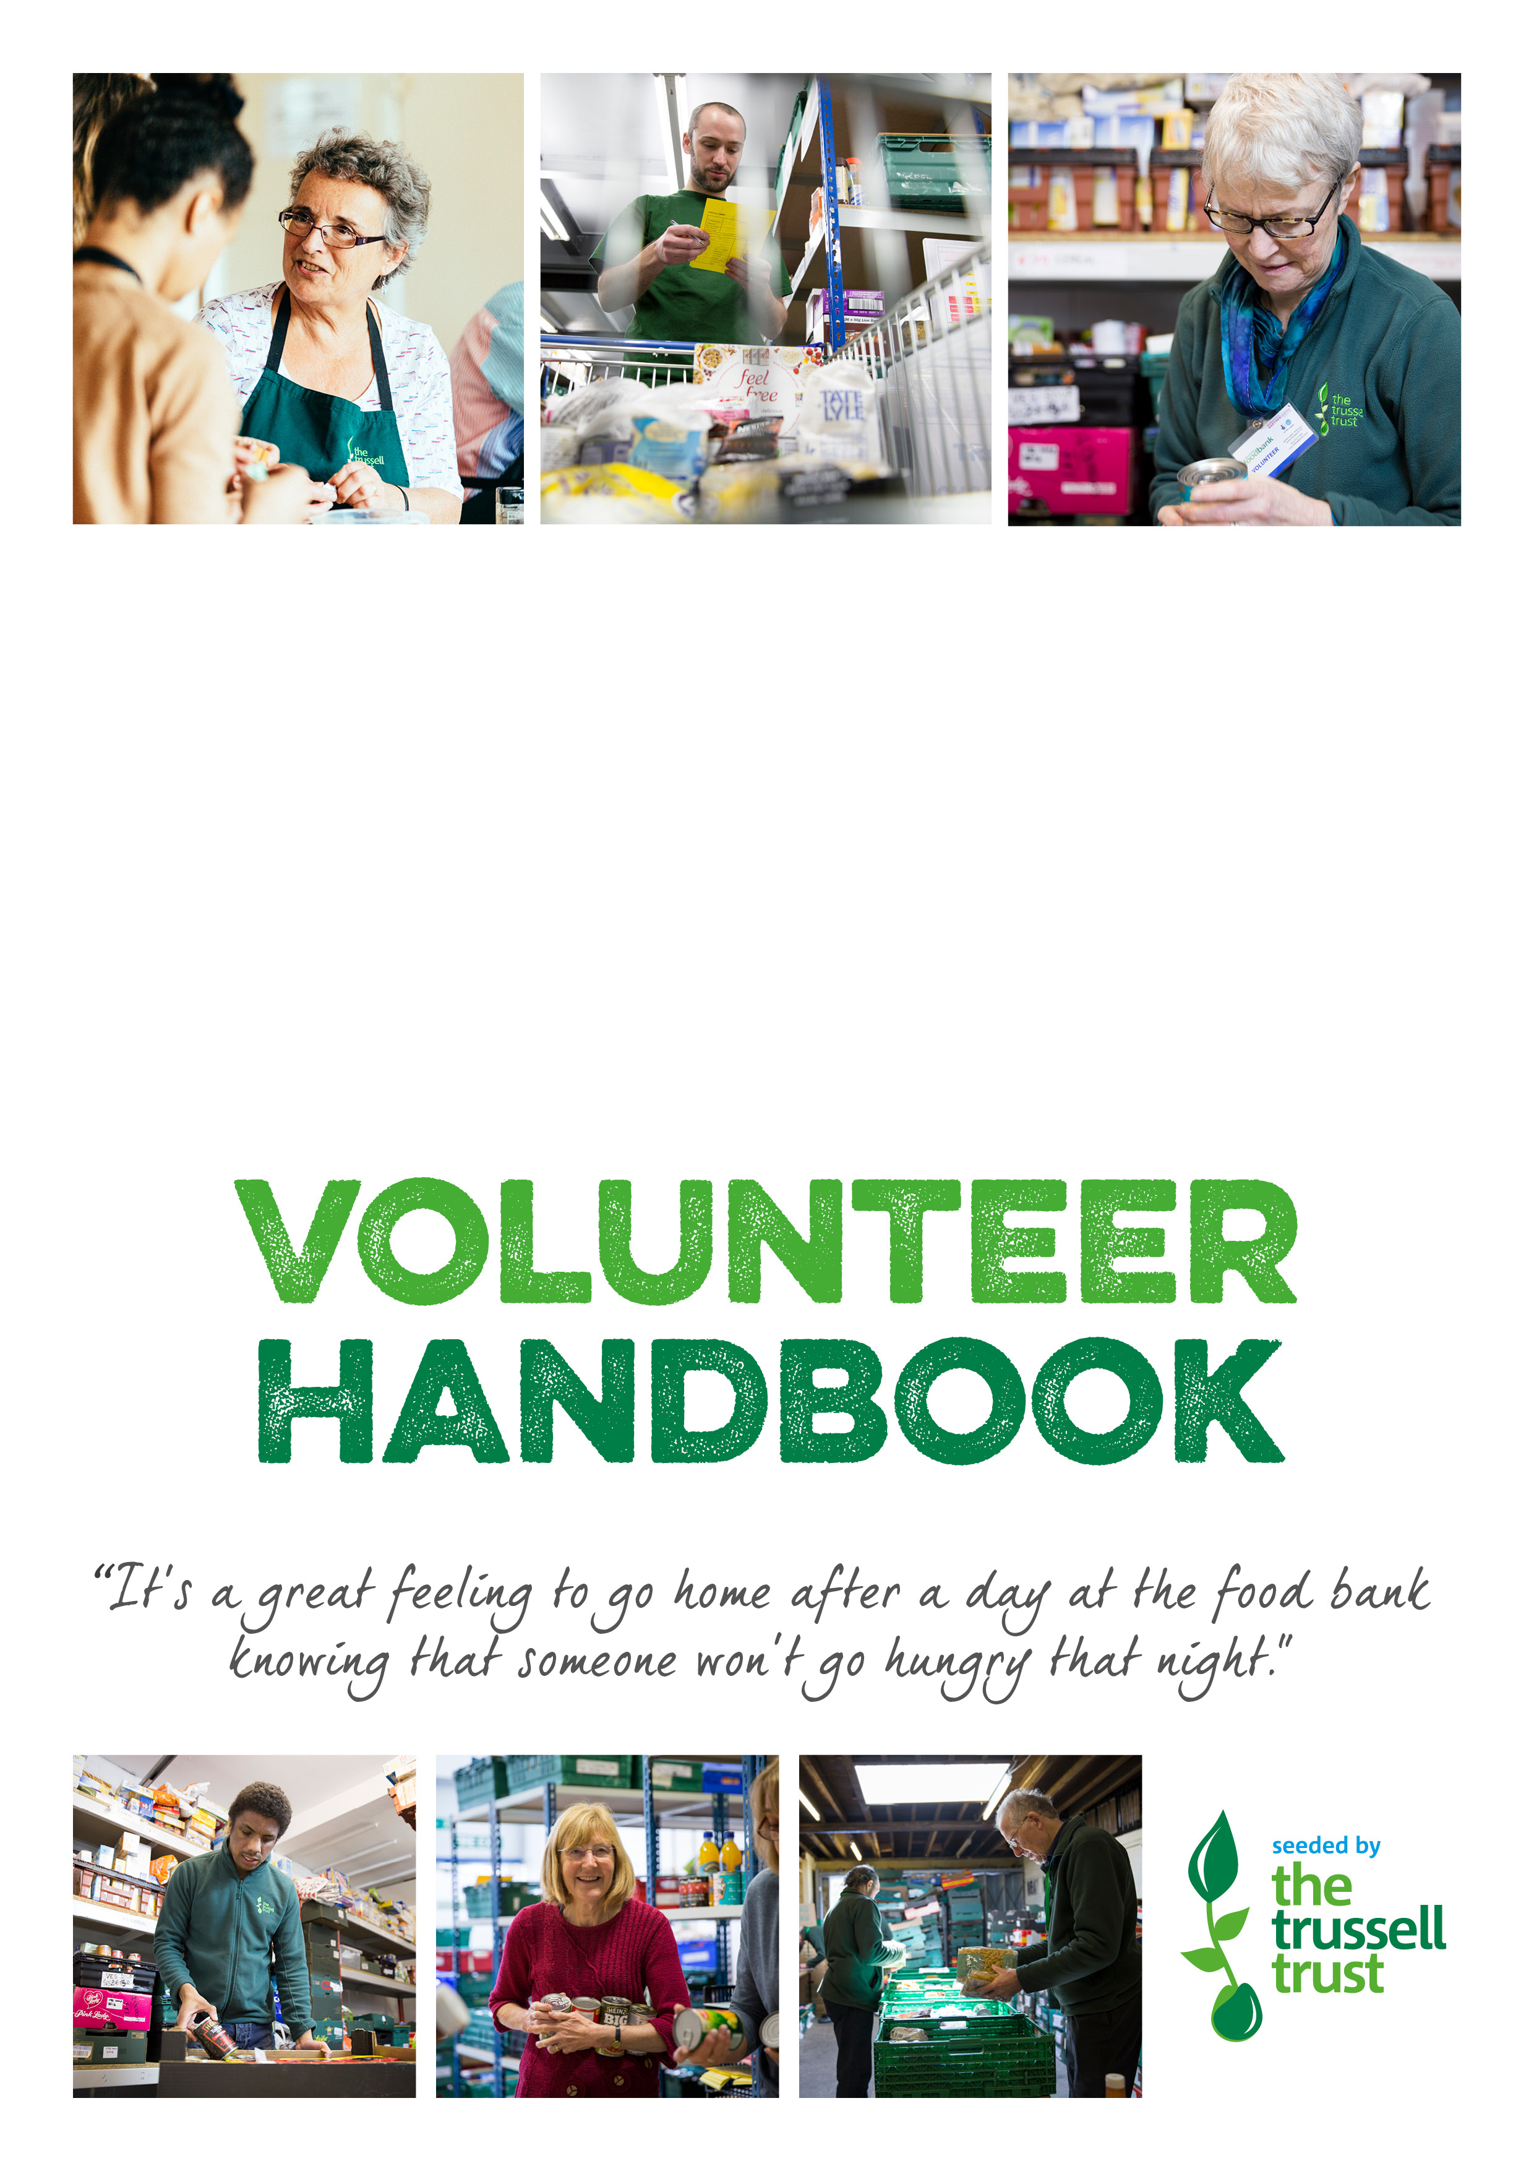

Glasgow NW Foodbank

Welcome to the Glasgow NW foodbank team.

Thank you for giving up your time, skills and knowledge to support us and help our local community. We’re delighted that you’ve decided to join our team. We hope you will enjoy your time with us.

This booklet is designed to give you a clear picture of how food banks are run and why we do it. It will also explain why, as well as to set out some general guidelines about volunteering with us.

Contact details
Glasgow NW foodbank:
Address: Blawarthill Church, Millbrix Avenue, Glasgow G14 0EP
Email address: info@glasgownw.foodbank.org.uk

Telephone: 0141 959 9813
Mobile phone: 07787 334012

Website: http://glasgownw.foodbank.org.uk

To find out more about The Trussell Trust please visit: www.trusselltrust.org

1. Glasgow NW Food bank

Every day people in Glasgow go hungry for reasons ranging from redundancy to receiving an unexpected bill on a low income. Glasgow NW food bank provides a minimum of three days’ emergency food and support to local people experiencing crisis.

Glasgow NW foodbank relies on the support of the local community through volunteering, food donations and fundraising. Almost all food is donated by the community through churches, schools, businesses, and supermarket collection days. Our clients are referred to us by over 250 frontline care professionals such as social workers, debt advisors, health visitors and teachers, who identify people in need, and give them a voucher they can exchange for a food parcel containing three days’ worth of nutritionally-balanced food at our foodbank centre(s). Sometimes we can also provide toiletries and items such as baby food and nappies. Volunteer drivers also deliver parcels, if required, and some agencies hold emergency boxes for us in the local area making sure that people can still access emergency food even if they can’t get to our foodbank centres

Volunteers are involved with every bit of the food bank. Volunteer roles include (but are not limited to) collecting and delivering donations, weighing and sorting donations, welcoming people, packing food parcels, preparing refreshments, liaising with local organisations and companies, providing administrative support, promoting the food bank on line, training, tidying and organising.

Our goal is to make the food bank a relaxed and friendly place, where volunteers and visitors feel welcome and safe.

The food bank is governed by Blawarthill Parish Church of Scotland, Glasgow and there are eighteen Elder trustees. More information about Glasgow NW food bank can be found at https://.glasgownw.foodbank.org.uk.

2. Our Values

The ethos of Glasgow NW food bank is based on Christian principles and on the teaching of Jesus Christ that God has a special care for the disadvantaged and marginalised in society, that He loves all people equally, and that he calls men and women to serve Him by serving and helping those suffering the effects of poverty and social exclusion. We do not expect all our supporters to be active Christians, but we hope that they will share these values.

3. The Trussell Trust

Glasgow NW food bank is part of a national network of food banks across the UK run by the Trussell Trust. The Trussell Trust is an anti-poverty charity founded on Christian principles. In this, the charity is guided by our values to be passionate, compassionate, accountable, innovative and empowering.

The story of the Trussell Trust began in 1997. In 1999 Salisbury food bank was set up with the aim of supporting people in crisis. In 2004 the UK food bank network was launched, resourcing and facilitating churches and communities nationwide to start their own food bank.

Today the Trussell Trust operates an extensive network of foodbanks throughout the UK. The charity also carries out research and campaigning work, in partnership with other organisations in the sector.

Glasgow NW foodbank is part of the Trussell Trust’s network providing us with access to:
- A Trussell Trust Area Manager, providing direct support
- The charity’s Operating Manual offering extensive guidance and editable resources
- Training
- a personalised website
- the data collection system, used to produce vouchers, record food donations and collect statistics about food bank usage.
- A branding pack with our logo and designs for leaflets, posters and banners.
- National and regional conferences and meetings.
- Corporate relationships brokered by the Trussell Trust such as Tesco food collections and cash top-up or access to surplus product donations from large companies.
- Funding grants administered by the Trussell Trust.
- Media opportunities and support from the Trussell Trust’s media team
Support and guidance from the Network Support team.

4. Joining our food bank - Code of Conduct / Volunteer Agreement

What you can expect from the Glasgow NW Food bank:
- to be integrated into the structure of the charity and actively contribute to a charity dedicated to end hunger and poverty
- to be recognised as equal partners in achieving the aims of the charity
- to be recruited fairly in line with our volunteer recruitment process
- to be welcomed and treated with courtesy and respect
- clear instructions, information and advice to assist you in your role as well as access to relevant training
- to be consulted and informed regarding any possible changes to your role
- regular reviews to ensure you are confident and comfortable in your role
- a named contact for support: your main contact is the Project Manager.
- to have your right to privacy respected
- recognition and thanks

Glasgow NW Foodbank expects volunteers to:
- uphold and champion the vision, mission and values of the Glasgow NW Foodbank
- remember that you are a representative of the charity
- collaborate positively with staff, volunteers, members of the public, clients and staff from partner organisations throughout your time as a volunteer
- be open and honest in your dealings with us
- treat everyone with dignity and respect
- communicate in an open and respectful way whether in person, by phone or using digital communications
- comply with relevant laws, guidance, policies and procedures
- remember that you have been put in a position of trust and that such should not be abused
- meet mutually agreed expectations around your role and to communicate with your Main Contact if these cannot be met
- let us know if we can improve the service and support that you receive
- let us know if you wish to change the nature of your volunteering role or if you are unable to continue as a volunteer
- avoid acting fraudulently or dishonestly or doing anything that will bring the charity into disrepute or have a negative impact on reputation

In support of this please ensure you:
- follow the guidance and practices in this Handbook and supporting documents
- notify the food bank as soon as possible if there are any changes to your contact details or emergency contact details.
- Let your main contact know if you are unable to attend any of the sessions you are signed up to, giving as much notice as is possible.

Our volunteers (definition)
A volunteer is someone who performs a task at the request of, or on behalf or, the charity. A volunteer does not receive financial compensation beyond the reimbursement of “out of pocket” expenses.
Volunteering for the Glasgow NW Foodbank is not a precursor to employment at the charity, nor are volunteers recruited to do the work of paid staff. No legally binding contract of employment or otherwise can be imposed on volunteers.

Recognition

Volunteers bring a huge amount of value through their time and commitment so at Glasgow NW Foodbank we will take the time to thank and recognise our volunteers. This will take the form of day to day activities such as regular communication and asking for your feedback. To special thank you events which also provide a great opportunity to socialise with other volunteers.

Learning and development

Every volunteer will have an induction when they start their role. This should cover health and safety requirements, task training, and meeting the team, as well as generally ensuring the person is comfortable, confident, and have all they need to do the task in hand safely. Regular catch ups with your main contact at the food bank will then provide the opportunity to identify any other training that will be of benefit.

Equality, diversity and inclusion
Glasgow NW Foodbank is committed to embracing diversity and promoting equality and inclusion. During your time volunteering you will be treated fairly regardless of gender, sexual orientation, age, parental or marital status, disability, religion, colour, race, ethnic or national origins or socio-economic background. As a volunteer we expect you to support our commitment to promoting this position.

We firmly believe that no one should be left out. Whatever the needs of our volunteers, we do our best to meet them by being flexible, inclusive and accommodating. We hope that all volunteers will actively seek to create supportive and happy teams, and, when needed, will ‘buddy’ with someone who needs a little more help to accomplish the task in hand.

Expenses
Glasgow NW Foodbank will pay for reasonable out of pocket expenses incurred whilst undertaking your volunteering role. Expenses should be discussed and agreed with your Main Contact in advance. This does not include travel expenses to and from the food bank centres.

Insurance, risk assessment and health and safety
The food bank has a duty of care to ensure all volunteers are operating in a safe environment. All volunteers are covered by the Glasgow NW Foodbank’s public liability insurance. A Health and Safety Policy and risks linked to the role will be talked through as part of your induction. Any training on use of personal protective equipment (PPE) necessary to carry out your role safely will be provided and training needs will be reviewed regularly.

Problem solving
Problems may arise in a number of different ways. A volunteer may make a complaint about another volunteer, a member of staff or the Glasgow NW Foodbank itself.
In cases of difficulty, the Glasgow NW Foodbank:
- endeavours to get it right from the beginning, by following guidance on good practice, having up to date policies and listening to the concerns of volunteers
- offers means to achieve reconciliation when things go awry by ensuring everyone knows what to do when something goes wrong, appointing somebody to monitor volunteers’ complaints and to explore independent means of conflict resolution when necessary
- accepts responsibility for ensuring volunteers’ complaints have a fair hearing

Any complaint (oral or written) will be examined quickly and effectively. If there is no satisfactory resolution the volunteer will be referred to a senior manager, up to and including the Board of Trustees who will provide a written response within 10 working days.

For further information please see our Volunteer Problem Solving Procedure.

Gross misconduct
Volunteers are expected to behave responsibly throughout their time with the charity. Normally we would bring any difficulties to your attention informally. However, the behaviour listed below would result in us refusing any further voluntary assistance from you:
- Grossly indecent or immoral behaviour, deliberate acts of unlawful discrimination or serious acts of harassment;
- Dangerous behaviour, fighting, or physical assault;
- Incapacity whilst volunteering, or poor performance caused by intoxicants, alcohol, or drugs;
- Possession, supply, or use of illegal drugs;
- Taking part in activities which result in adverse publicity for ourselves;
- Theft or unauthorised possession of money or property, whether belonging to us, another employee or volunteer, or a third party;
- Destruction or sabotage of our property, or any other property on the premises;
- Serious breaches of Health and Safety procedures;
- Maltreatment of volunteers, staff, people visiting the food bank, other visitors or donors;
- Failure to report an incident of abuse, or suspected abuse, of a service user by an employee, other volunteer, or member of the public; and
- Convictions for any offence which may affect your suitability for the volunteering duties you are involved in.
Please note that a criminal record will not necessarily preclude you from volunteering, but we may need to make an assessment of any risks both to you and to others.

Safeguarding
We take safeguarding very seriously and are committed to fulfilling the requirements of the Protection of Vulnerable Groups (Scotland) Act 2007, the Disclosure and Barring Scheme and other relevant legislation aimed at the protection of vulnerable people. The charity ensures it promotes a safe environment for children and vulnerable adults.

All volunteers for the charity have a responsibility to follow best practice and to pass on any welfare concerns in line with our Safeguarding Policy. Remember, safeguarding is the responsibility of all of us; if you spot something, make sure you immediately follow the training and guidance you receive.

Allegations which involve potentially criminal activities will be reported immediately to the police.

Confidentiality and Data Protection
The charity fully complies with the requirements under GDPR and PECR and volunteers must do so too. Whilst volunteering your may have access to or learn of information of a confidential nature. We expect all volunteers to comply with our Confidentiality Policy and Data Protection Policy.

Volunteers will not, either during their time at the charity or thereafter, use to the detriment or prejudice of the charity any confidential information about the charity or other information designated as confidential.

Statements to the media
Any media enquiries must be directed to your Main Contact. You may be approached by your Main Contact to support a campaign or take part in an interview. Please note that volunteers must not make any statements to the media without the express permission of the Food bank Project Manager.
From time to time photographs or filming may take place at the food bank. Please ensure you have signed our permission form so that we can use your images. If you do not wish to be photographed or filmed, you are responsible for letting the photographer/cameraman know at the time.

5. General standards
Driving
If it is a requirement of your volunteering role to possess a current driving licence and to drive for the charity then you are required to read and comply with the food bank’s Driving policy

Standard car insurance policies cover social use and commuting. Business cover covers a wider range of use such as travelling between different work locations, visiting customers or transporting business products and people.
Standard car insurance policies cover social use and commuting. As such, commuting to and from the food bank in your car shouldn’t require business cover. However, cover does vary depending on the provider. For more information visit: https://www.abi.org.uk/globalassets/files/publications/public/motor/2019/abi-guide-to-volunteer-driving---the-motor-insurance-commitment.pdf

Minimum waste
We maintain a commitment to “minimum waste” which is essential to the cost effective and efficient running of the charity.
You can support this by:
- Handling machines, equipment and stock with care
- Turning off any unnecessary lighting and heating
- Being punctual
- Seeking additional tasks, if appropriate, if you complete your activity.

Personal property
No liability is accepted for any loss of, or damage to, personal belongings or property brought onto our premises, or our clients’ premises. You are advised not to bring any personal items of value with you to work or, in particular, leave any items here overnight.
Volunteers are asked not to take mobile phones, wallets or bags into your working area – these must be placed in the designated areas provided.
Articles of lost property should be handed to your Main Contact.

Use of Computer Equipment
You may be required to use the internet or email system to carry out your duties. Any unauthorised use of either (e.g. for engaging in the dissemination of offensive or confidential content, bullying, piracy or other illegal activity, pornography, gambling, copyright infringement, or personal use unrelated to your task) may be regarded as gross misconduct.
You may be allowed to use the internet for personal tasks during break times but you must ask the Project Manager’s/volunteer coordinator’s permission.
No new software may be added (whether by CD-ROM, USB flash drive, download or any other means), copied or removed from our computers without the permission of the Project Manager.
For further information please see our IT and Communications policy

Smoking:
Smoking is not permitted inside any of our buildings or close to any door or window. If we have provided you with over-garments e.g. tabards, please remove them before smoking. If we have provided you with branded clothing e.g. a polo shirt, please change into your own clothes before smoking (including e-cigarettes).

Suitable Clothing:
You are likely to coming into contact with a range of people during your volunteering. As such, we ask that you maintain a neat and tidy appearance at all times. You should wear clean clothes appropriate to your role and activities. If you are volunteering in the warehouse you should wear footwear with closed toes and warm clothes, particularly during the winter months when it can get cold.
If provided with branded clothing and name badges please ensure that they are worn for the duration of your volunteering session.

Protection of Minors and Young People:
We have a responsibility to see that minors while helping out at the foodbank are afforded the protection consistent with our Safeguarding Policy.
This is expected to be complied with by all volunteers and staff. A copy of the Safeguarding policy will be given to you to read at your induction and is also on display at the foodbank centre{s} and warehouse.
We would appreciate if you would please be team minded and help any volunteers needing support (if you are safely able to), especially younger people who may not be able to lift or move things or work at height.

Lone volunteering
For safety reasons we aim to ensure nobody volunteers alone. Volunteers visiting a food bank centre or the warehouse when no-one else is present must notify the Project Manager/volunteer coordinator by text or phone of their arrival, and alert when they leave or are joined by another. Ladders and steps must never be used unaccompanied and doors should be locked, with the key kept in the lock should you need to make a quick exit. Food deliveries to clients’ home addresses must not be undertaken unless accompanied by another adult volunteer or employee. For more information please see our Lone Volunteering Guidance

Closed circuit television
Closed circuit television cameras are used on some of our premises for security purposes. We reserve the right to use any evidence obtained in this manner to handle complaints or problem solving issues.

